Module 11 – Dashboards and Stories in Tableau
11.1 What is a Dashboard?
A Dashboard in Tableau is a collection of multiple worksheets, charts, filters, legends, and objects displayed on a single screen to provide a complete business view.
Benefits of Dashboards
- Combine multiple visualizations in one place
- Monitor KPIs and performance metrics
- Enable interactive analysis
- Support business decision-making
- Provide a professional reporting interface
Dashboard Example
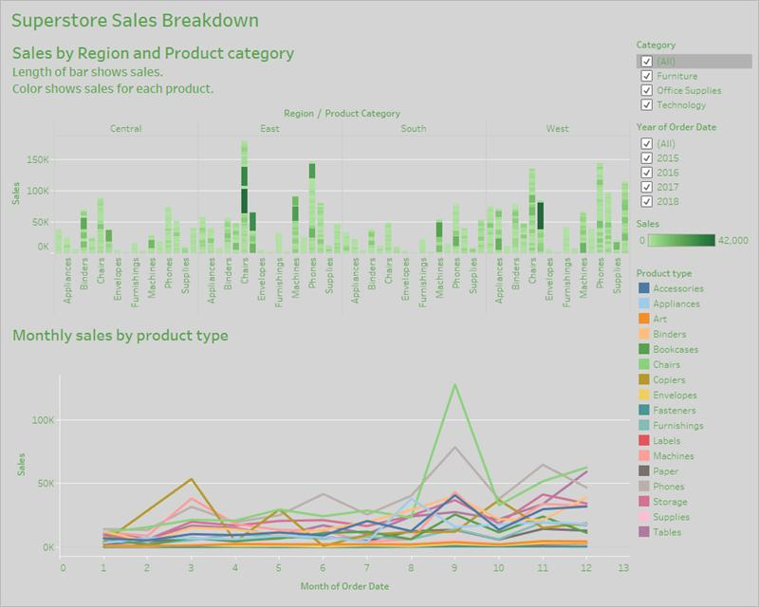
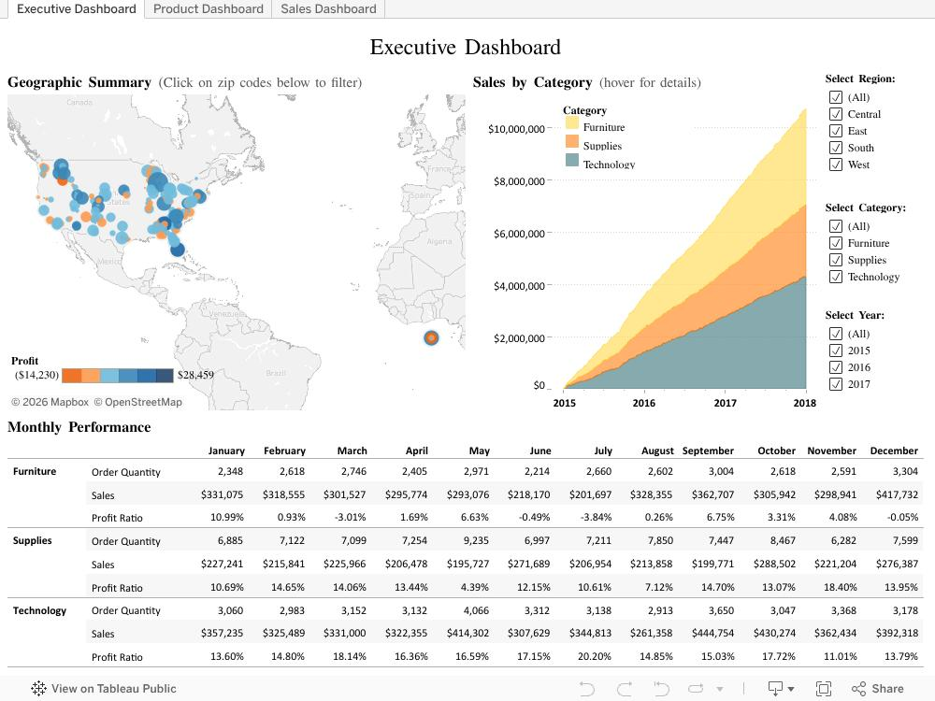
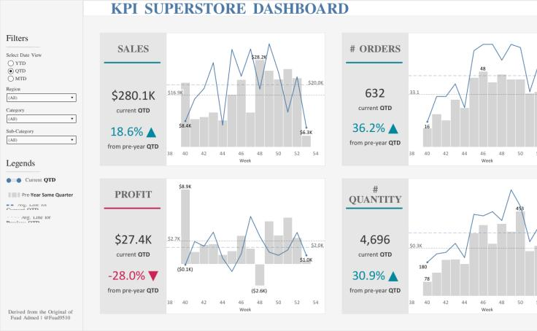

11.2 Building and Formatting a Dashboard
Step 1: Create Worksheets
Build required visualizations such as:
- Sales Trend
- Profit Analysis
- Category Performance
- Regional Analysis
Step 2: Create Dashboard
- Open Tableau.
- Click New Dashboard icon.
- Dashboard pane appears.
Step 3: Set Dashboard Size
Dashboard Pane → Size
Options:
- Automatic
- Fixed Size
- Range
Example:
- Desktop Browser (1200 × 800)
Step 4: Add Objects
Drag objects from Dashboard Pane:
Horizontal Container
Arrange charts horizontally.
Vertical Container
Arrange charts vertically.
Text
Add dashboard titles.
Image
Add company logo.
Web Page
Display external webpage.
Blank
Add spacing between objects.
Step 5: Add Worksheets
Drag worksheets onto dashboard canvas.
Step 6: Add Filters
- Click worksheet dropdown.
- Select:
  - Filters
  - Show Filter
Step 7: Add Legends
Worksheet Dropdown → Legends
Options:
- Color Legend
- Size Legend
- Shape Legend
Dashboard Layout Example
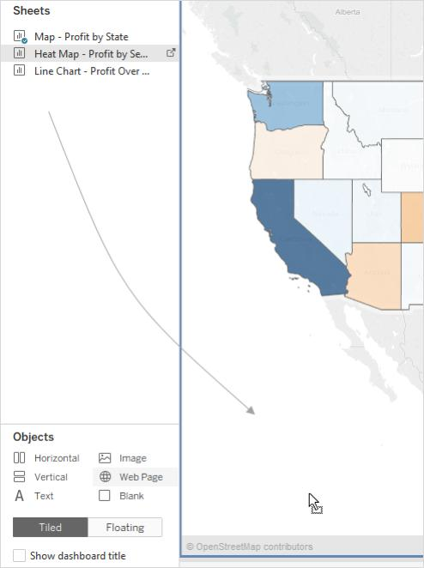
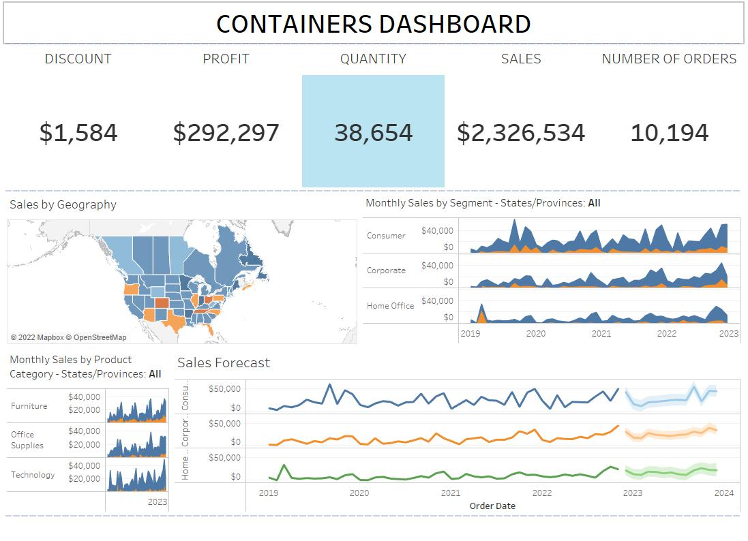
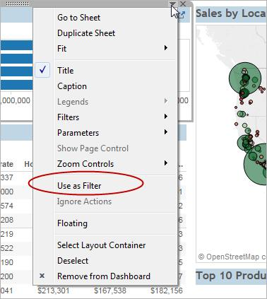

11.3 Best Practices for Creative and Interactive Dashboards
Design Best Practices
1. Keep It Simple
- Avoid too many charts.
- Focus on business objectives.
2. Use Consistent Colors
- Maintain branding.
- Use meaningful color coding.
3. Place Important KPIs at Top
Example:
- Total Sales
- Profit
- Orders
4. Use Interactive Filters
Allow users to:
- Select Region
- Select Category
- Select Year
5. Maintain Proper Alignment
Use containers for professional layouts.
6. Optimize Performance
- Reduce excessive calculations.
- Use extracts when possible.

Dashboard Actions
Actions create interactivity.
Types of Actions
- Filter Action
- Highlight Action
- URL Action
- Go to Sheet Action
Creating an Action
Step 1:
Dashboard → Actions
Step 2:
Click Add Action
Step 3:
Select desired action type
Step 4:
Configure source and target sheets
Step 5:
Click OK

11.4 Creating Stories
What is a Story?
A Story is a sequence of worksheets and dashboards used to present data findings in a storytelling format.
Stories help:
- Explain trends
- Present business insights
- Show analysis step-by-step

Creating a Story
Step 1
Click New Story icon.
Step 2
Choose Story Size.
Step 3
Add Dashboard or Worksheet.
Step 4
Create Story Point.
Step 5
Add captions and descriptions.

Introduction to Story Points
A Story Point is a single slide/page within a Tableau Story.
Each story point represents:
- A finding
- A trend
- A business insight
Example:
Story Point 1:
Overall Sales
Story Point 2:
Regional Analysis
Story Point 3:
Profitability Analysis
Story Point 4:
Recommendations

Creating and Updating Story Points
Create New Story Point
- Click New Blank Story Point.
- Drag worksheet/dashboard.
- Add title.
Duplicate Story Point
- Right-click story point.
- Duplicate.
- Modify analysis.
Update Story Point
- Modify worksheet/dashboard.
- Click Update button.

Adding Catchy Visuals in Stories
Use:
- KPI Cards
- Maps
- Trend Charts
- Highlight Tables
- Images
- Company Logos
Story Example
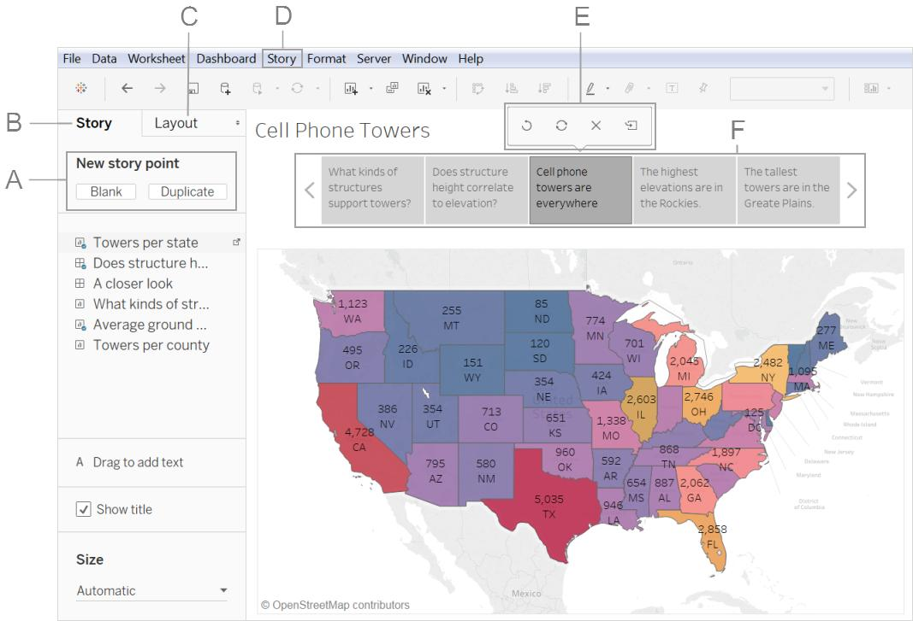
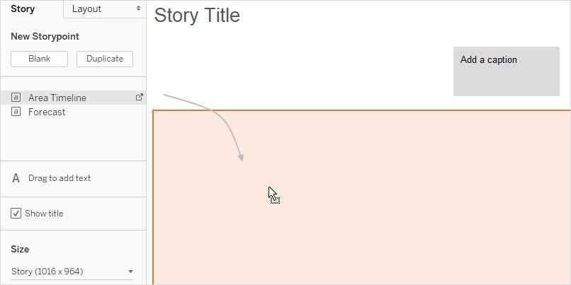
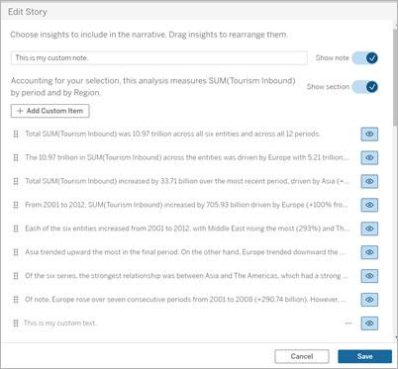

11.5 Adding Annotations with Descriptions
Annotations help explain important data points.
Types of Annotations
Mark Annotation
Attached to a data mark.
Point Annotation
Attached to a specific point.
Area Annotation
Attached to an area.

Steps to Add Annotation
Step 1
Right-click any mark.
Step 2
Select:
Annotate → Mark
Step 3
Enter description.
Step 4
Format annotation.
Example
Sales Peak:
"Highest sales achieved during Diwali season."
Benefits:
- Explain trends
- Highlight outliers
- Present business insights

11.6 Highlight Actions, URL Actions, and Filter Actions
Highlight Action
Highlights related data.
Steps
- Dashboard
- Actions
- Add Action
- Highlight
Example:
Hover over Region → Related categories highlighted.

URL Action
Opens webpage when user clicks data.
Steps
- Dashboard
- Actions
- Add Action
- URL
Example:
Click Product → Product webpage opens.

Filter Action
Filters target worksheet.
Steps
- Dashboard
- Actions
- Add Action
- Filter
Example:
Click Region → Only region data displayed.

11.7 Selecting and Clearing Values
Selecting Values
Users can:
- Click marks
- Use filters
- Select categories
- Multi-select values
Methods
Single Select
Click one mark.
Multi Select
Ctrl + Click
Lasso Selection
Use lasso tool.
Rectangle Selection
Drag mouse over marks.

Clearing Values
https://chatgpt.com/c/6a314aba-4974-83ee-b0da-fc5107f0a6c1
Method 1
Click empty area.
Method 2
Use Revert button.
Method 3
Clear filter selections.
Method 4
Dashboard → Actions → Exclude All Values

11.8 Dashboard Examples Using Tableau Workspace and Interface
Sales Dashboard
Components:
- KPI Cards
- Sales Trend
- Region Map
- Category Analysis
- Filters
HR Dashboard
Components:
- Employee Count
- Department Analysis
- Attrition Rate
- Gender Distribution
Finance Dashboard
Components:
- Revenue
- Profit
- Expenses
- Forecast Analysis
Executive Dashboard
Components:
- KPIs
- Trends
- Performance Indicators
- Business Summary
Tableau Dashboard Workspace Example
